1. Dataviz Best Practices
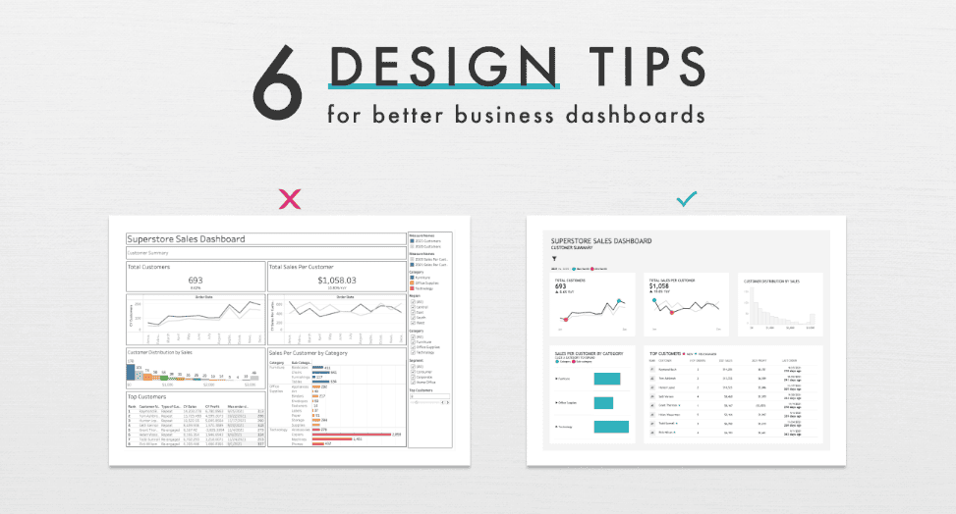
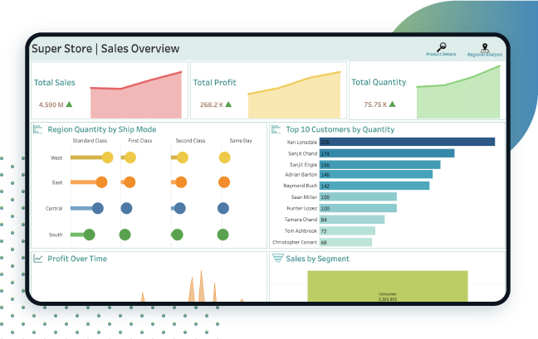
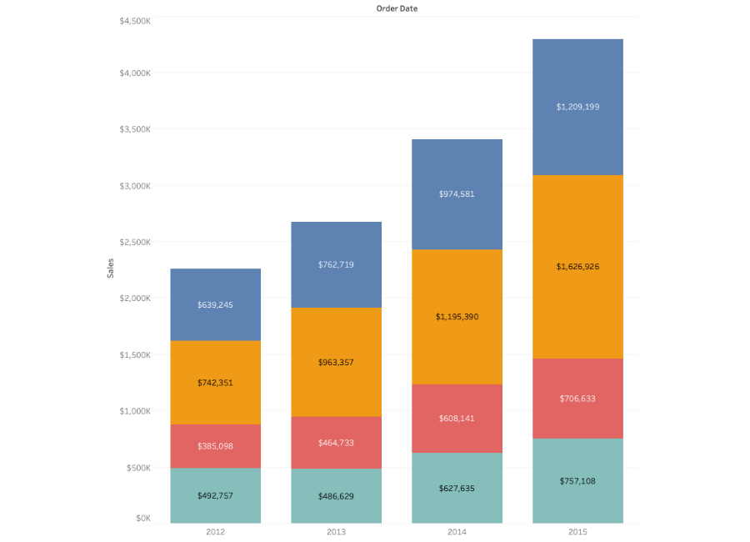
4
Follow these guidelines:
- Keep visuals simple
Prefer bar charts, line charts, scatter plots for most cases.
- Avoid unnecessary colors
Use color only when it adds meaning, like grouping by Category or Region.
- Sort from highest to lowest
Easier for the viewer to compare.
- Limit 3D or decorative visuals
3D distorts value perception and reduces readability.
- Keep dashboards focused
One main question per dashboard. If you need more, create more dashboards.

2. Creating Simple Calculations in Tableau
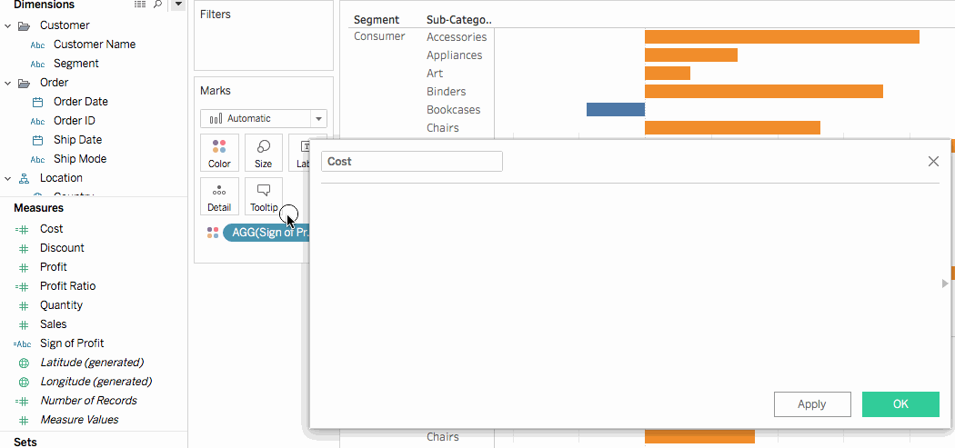
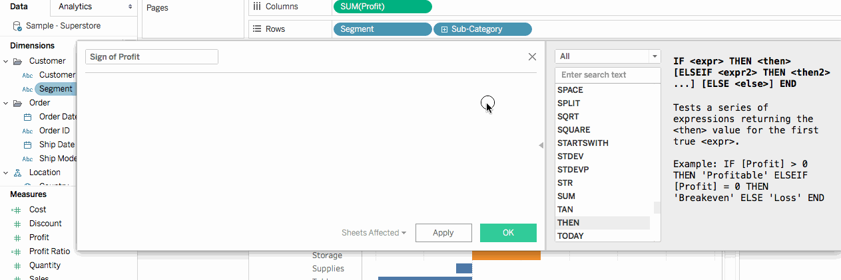
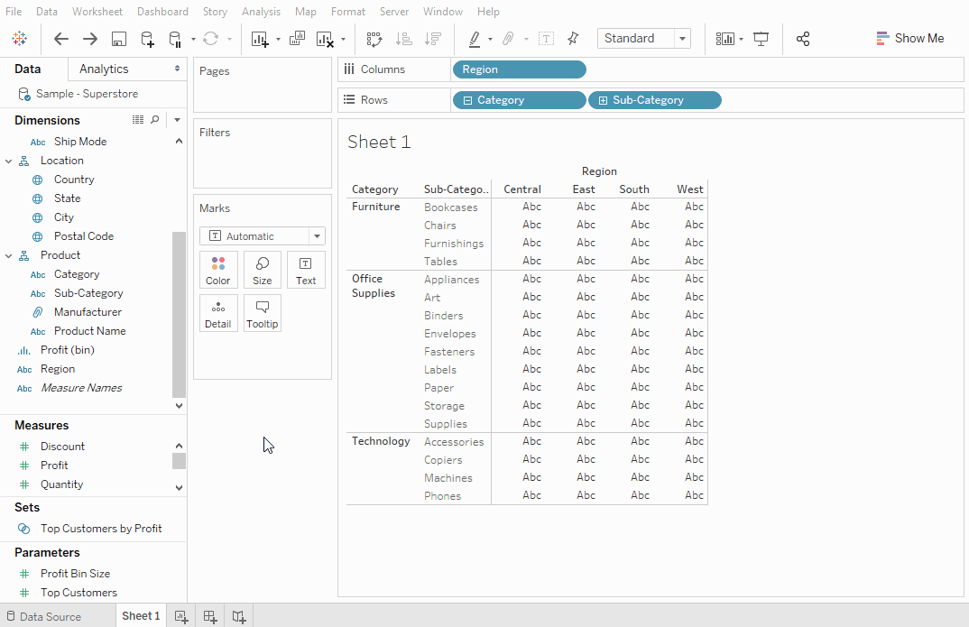
4
Example: Profit Ratio
This calculates how much profit you make from sales.
Steps
- Open any worksheet.
- Right click in the Data Pane (left side of screen).
- Select Create > Calculated Field.
- Give a name, for example:
- Profit Ratio
- Enter formula:
- [Profit] / [Sales]
- Click OK.
Use it in visualization
- Drag Profit Ratio to Color or Label to highlight categories with strong profit.

3. Using Table Calculations
Table calculations perform additional computations on top of existing visual data.
A. Running Total
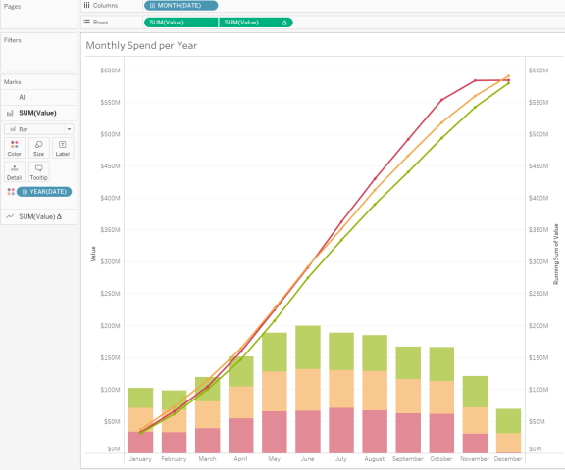
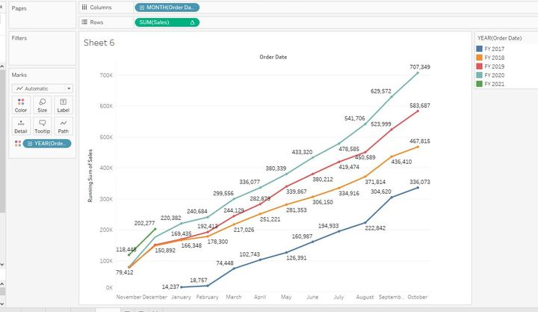
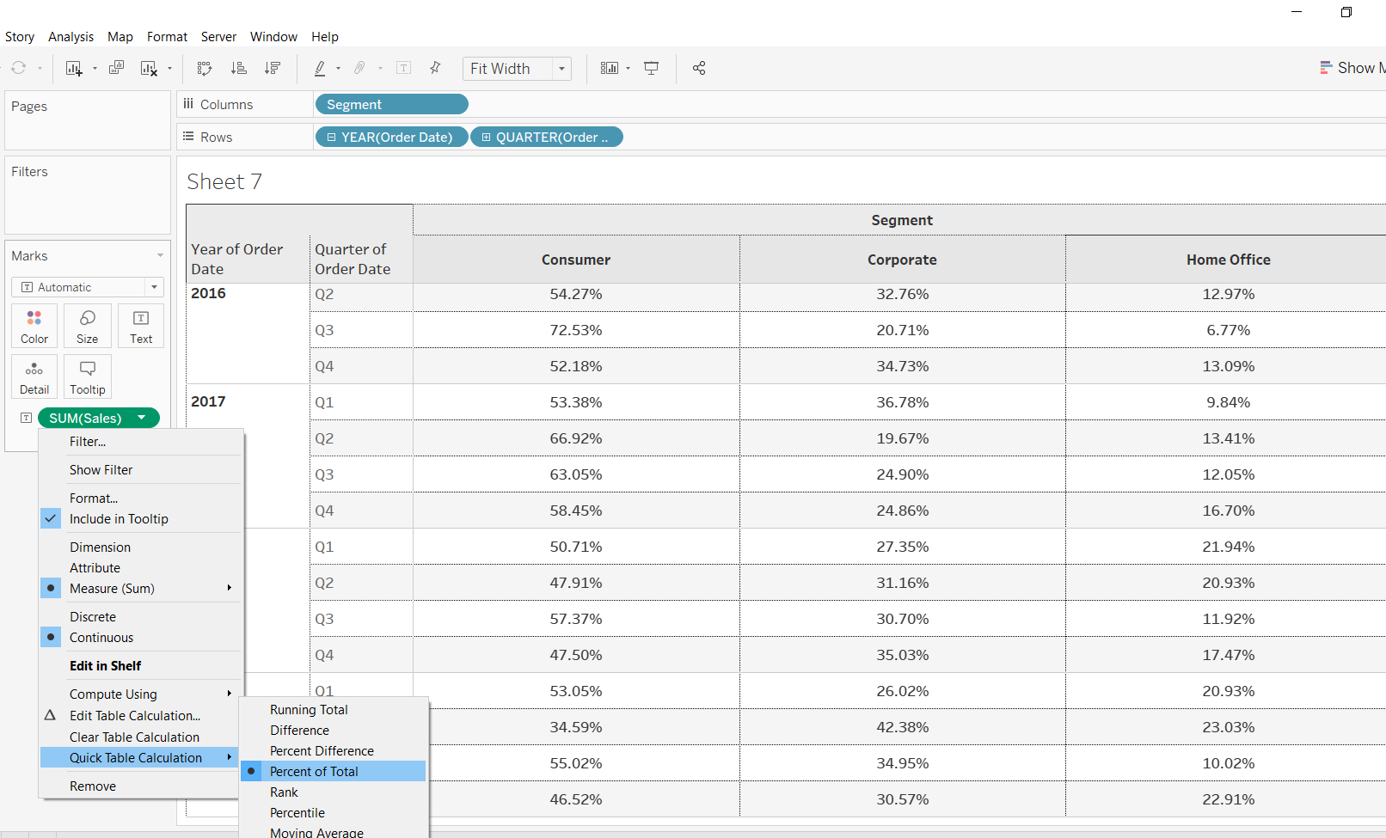
4
Steps
- Create a line chart: Order Date → Columns, Sales → Rows.
- Right click SUM(Sales) on the view.
- Choose Add Table Calculation.
- Select Running Total.
- The line becomes cumulative over time.

B. Percent of Total
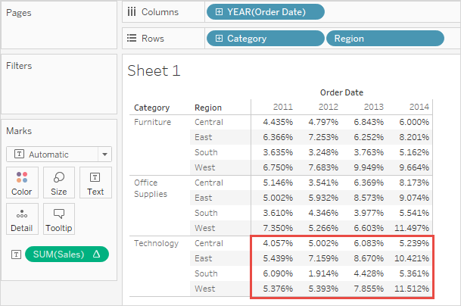
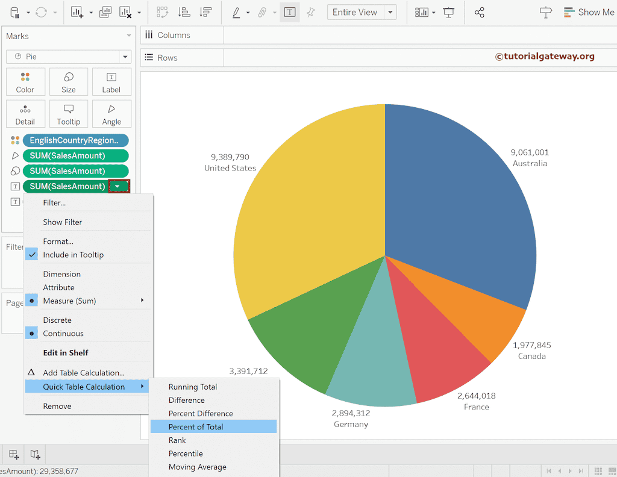
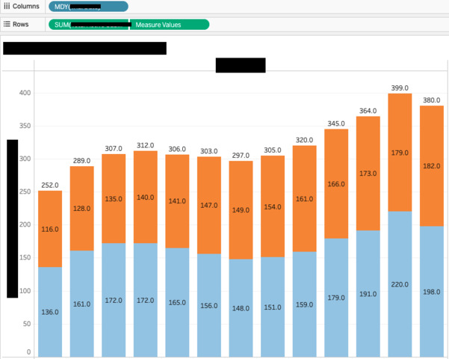
4
Steps
- Create a bar chart: Category → Rows, Sales → Columns.
- Right click SUM(Sales).
- Choose Quick Table Calculation → Percent of Total.
- The bars now show each category’s share of total sales.

C. Moving Average
Useful for time-based trend smoothing.
Steps
- Create a line chart of Sales over Order Date.
- Right click SUM(Sales).
- Select Add Table Calculation.
- Choose Moving Average.
- Pick window size, for example: 3 months.

